**Title**

**Intro (Large text + more old person)**

Problems of elderly

* elderly are less healthy
* difficulty walking
* remembering to take medication
* lonely

Why is this problem important

* falling or forgetting to take meds a single time can pose immense health threat
* 129 suicides in singapore, an all time high <https://www.straitstimes.com/singapore/number-of-suicides-among-seniors-hits-record-high>

**Introduction**

The world’s elderly population is at its highest proportion in history, and projected to grow to 17% of the world’s population by 2050. This has increased the necessity for elderly care, including health monitoring and home assistance; forgetting to take medication can present an immense danger to health. Loneliness and mental health issues are also prevalent in the aged population, with suicides for individuals aged 60 and above hitting a record high in 2017.

The system proposed is an affective companion robot for the elderly. It provides a variety of assistive, communicative, and health tracking features. A second main goal is to alleviate loneliness; there exists strong evidence that the presence of a pet companion is beneficial to mental health.

**History (Med text + 1 bot)**

Pepper is an affective healthcare robot in Japanese nursing homes that can identify visitors and make appointments. However, it is not designed for domestic use, having no personalized functions, and costing 200,000 JPY. It cannot keep track of an individual’s health, nor provide them with a companion.

Therefore, the objective of this project is to create a robot for domestic use that can be manufactured with low-cost hardware components.

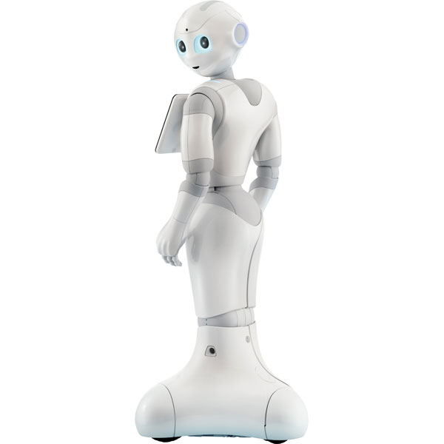

**Proposition (large + 3 small icons)**

What are the things you want to do + IMAGE. Why?

To provide elderly individuals with a pet companion that is useful yet friendly.

icon Home Assistant: Sends and receives text and voice messages, and news headlines. Moves to the door and takes a photo, identifying the visitor before the individual has to get up.

icon Health Monitor: Checks in on the individual at intervals, taking photos and sending them to their loved ones. Monitors heart rate, location.

icon Affective Companion: Moves around, and provides a companion to talk to. Reminds them to take their medication.

These features will assist with home tasks to reduce dangers that can arise from small accidents in the home, while providing the individual with a friendly companion.

//taking care of pets benefits mental health

**Research Method (single arrow) & Implementation (large image + small text)**

Different approaches

* home system. however, ended up choosing bot. Use affecive computing to assume role of pet. Goal of Alleviate loneliness.

A home system was initially considered. However, this would not fulfil the goal of providing a companion to alleviate loneliness. Therefore, the robot with a physical presence was chosen.

How to implement

Images of equipment + list

* rpi: Controlling computer system
* arduino: controlling hardware
* speaker //ask for one : to send recorded audio messages
* bluetooth module : to send text message to phone
* infrared sensor : floor tracking
* sonar sensor: detect obstacles
* camera (for detection of you) : model: to take photos of
* microphone? (or future) //ask for one: to record X
* movement: uses the bou algo
* separate motors: can rotate on the spot

**Result (small text bubbles + 1 graph)**

**Conclusion (small text)**

Fast facial recognition and personalization is feasible with more economically-priced hardware. This open an affordable solution to the mass-market demand for affective computing.

**Future**

* Heart Rate although more invasive
* sleep tracking
* more affective computing (like a pet). survey to measure acceptability